Pensioner Ezekiel McCarthy Avoids Prison after Killing Nephew Desbert Welsh
- Article
By Ewan Palmer: Subscribe to Ewan's RSS feed
December 4, 2012 6:53 PM GMT
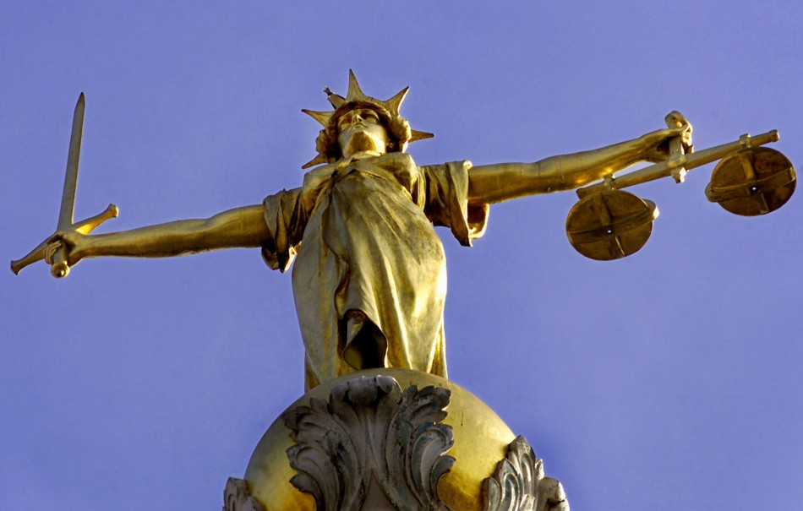
McCarthy was one of the oldest defendants to appear at the Old Bailey (Reuters)
An 85-year-old man who admitted killing his nephew after he mistook him for a burglar has walked free from court with a suspended sentence.
Ezekiel McCarthy was originally handed a nine-month sentence after he pleaded guilty by reason of diminished responsibility to the manslaughter of Desbert Welsh, 50, at his flat in Cricklewood, north London in 2011.
But the sentence was suspended for two years on condition that the 85-year-old, who was one of the oldest people to appear in the dock at the Old Bailey, was supervised during that period.
Judge Peter Beaumont concluded it was very unlikely McCarthy would offend again during this time.
McCarthy stabbed his nephew in November 2011 after the pair had been out drinking to celebrate the older man's birthday. The court heard how McCarthy had been confused at the time of the killing, telling police: "This bloody man. I don't know how he got in my room."
Follow us
He later said he was defending himself during the incident at his ground floor at Brondesbury Park. Medical reports revealed that McCarthy had suffered an acute episode of delirium or confusion due to medical conditions linked to his age.
Beaumont, the Recorder of London, told him: "You took the life of a wholly innocent man who had shown you nothing but friendship and support."
But Beaumont added he had received reports, including from other members of his family, which showed what type of person the 85-year-old actually was.
Jonathan Rees, QC, prosecuting, said: "This is a dreadfully sad case involving the killing of a nephew by his uncle, thinking he was an unknown intruder."
Alex Milne QC, defending, added: "He is destroyed. He is mortified. He could not in his wildest dreams harm his nephew."
Welsh died three days after the stabbing which pierced his liver.
This article is copyrighted by IBTimes.co.uk, the business news leader

